# SQL Project

## 1. Select all columns from the 'employee' table:

SELECT * FROM employee

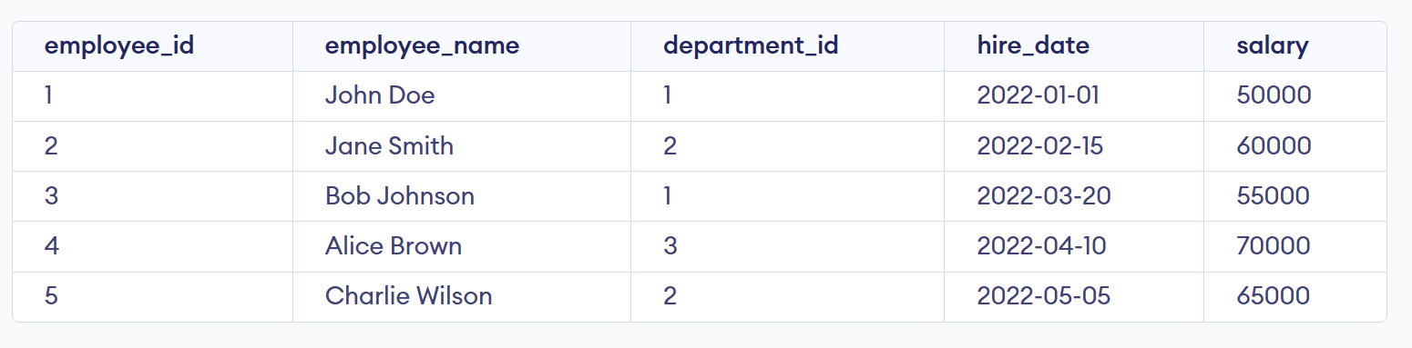

## 2. Select unique department names from the 'department' table:

SELECT DISTINCT department_name FROM department

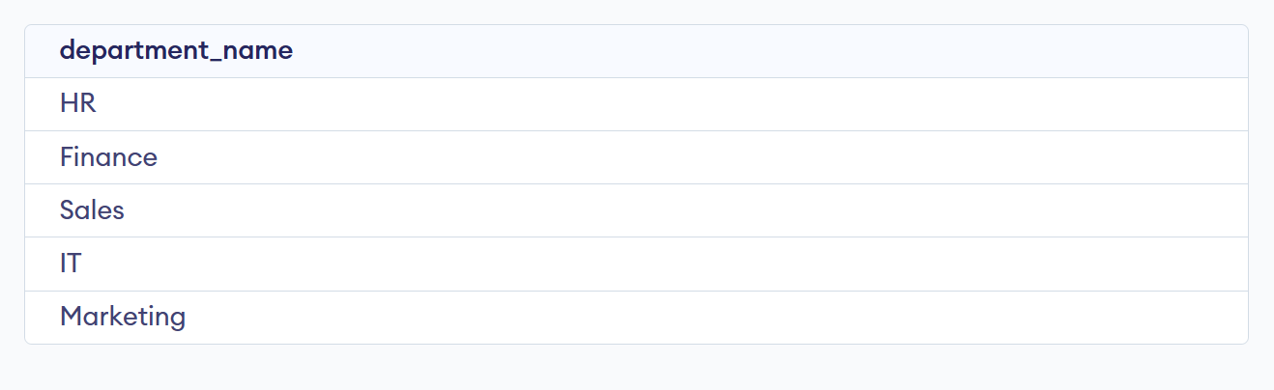

## 3. Select employee names and salaries from the 'employee' table, ordered by salary in descending order:

SELECT employee_name, salary FROM Employee ORDER BY salary DESC

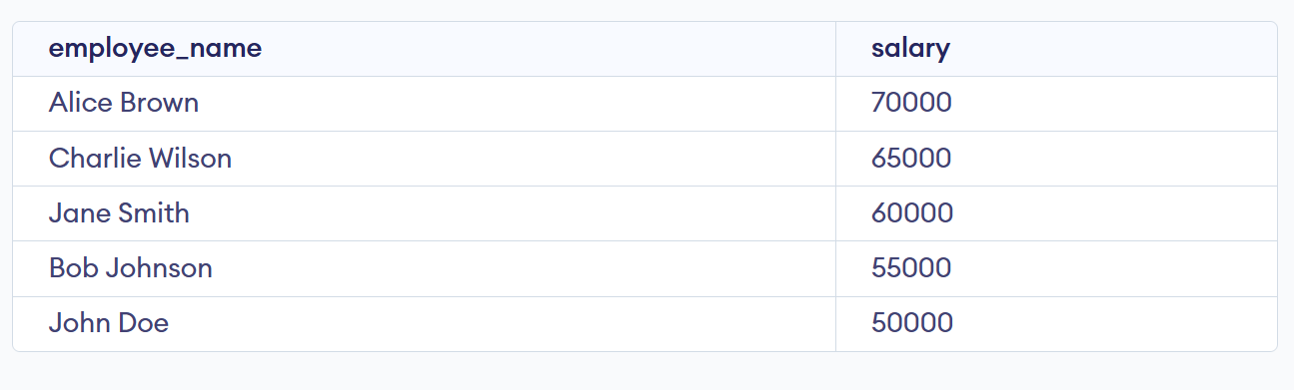

## 4. Select products with a price between £100 and £500 from the 'product' table:

SELECT * FROM Product WHERE price BETWEEN 100 AND 500

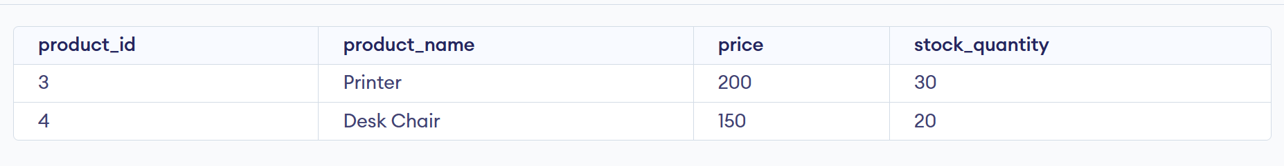

## 5. Select orders made by employees in the 'IT' department, joining 'purchase' and 'employee' tables:

The correct query to resolve this exercise is the following:

SELECT order_id, order_date, employee_name

FROM purchase

JOIN employee ON employee.employee_id = purchase.employee_id

WHERE employee.department_id = (SELECT department_id FROM Department WHERE department_name = "IT");

However, this results in no output data, which differs from the expected output shown in the course. The expected output shows the employee’s name Alice Brown, who is in the Sales department. The query to obtain said employee is the following:

SELECT order_id, order_date, employee_name

FROM purchase

JOIN employee ON employee.employee_id = purchase.employee_id

WHERE employee.department_id = (SELECT department_id FROM Department WHERE department_name = "Sales");

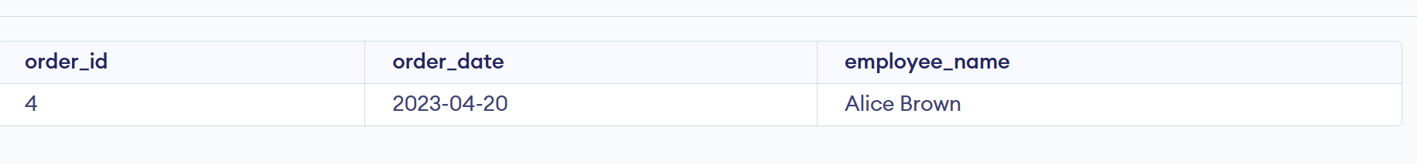

## 6. Select products with names containing 'Chair' using a wildcard:

SELECT product_id, product_name, price, stock_quantity FROM product WHERE product_name LIKE "%Chair%"



## 7. Select orders made by employees with IDs 1, 3, and 5:

SELECT order_id, employee.employee_id, product_id, order_date, quantity

FROM employee

JOIN purchase on employee.employee_id = purchase.employee_id

WHERE purchase.employee_id IN (1, 3, 5)

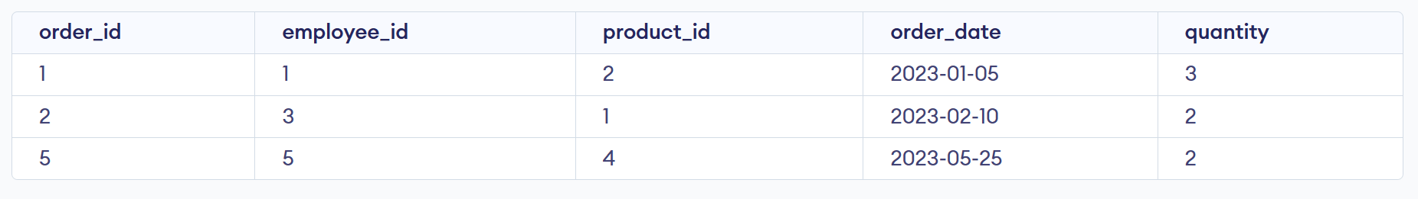

## 8. Select the average salary of all employees:

SELECT AVG (salary) AS average_salary from employee



## 9. Select employees hired after '2022-03-01' with a salary greater than £60000:

SELECT employee_id, employee_name, department_id, hire_date, salary

FROM employee

WHERE hire_date > 2022-03-01 AND salary > 60000

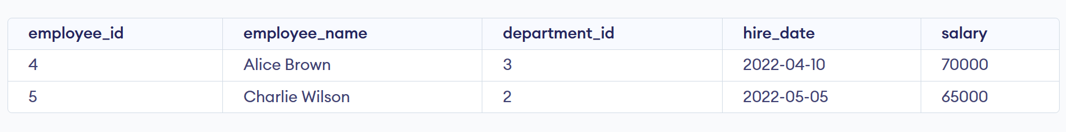

## 10. Select departments with more than 1 employees, counting the number of employees in each department:

SELECT department.department_id, department_name, COUNT (Employee.department_id) AS num_employees

FROM department

JOIN employee ON department.department_id = employee.department_id

GROUP BY department.department_id, department_name

HAVING num_employees > 1;

